- Centauro

Serial number start: 1000000.
Serial number end: 0

Json Request & Response
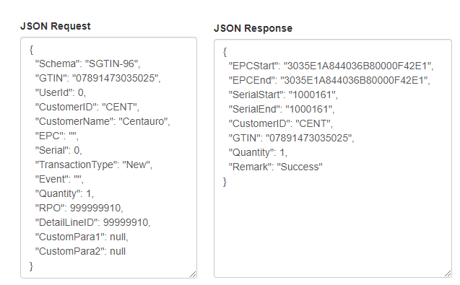

The affected tables are ‘tblEPCSerila’ and ‘tblEPCLog’

EPC Encoder/Decoder tool

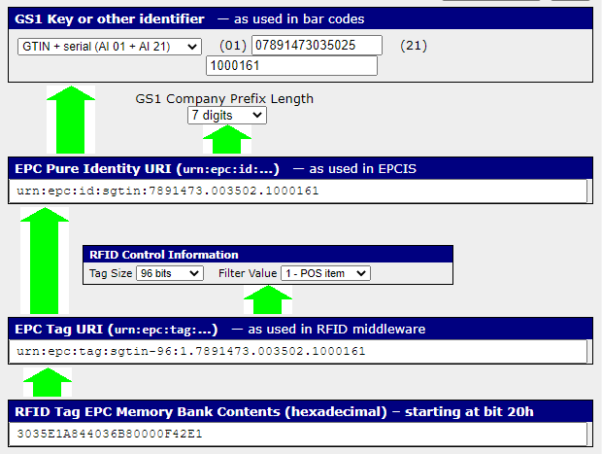

- Lacoste

Serial number start: 20000000001.
Serial number end: 0

Json Request & Response

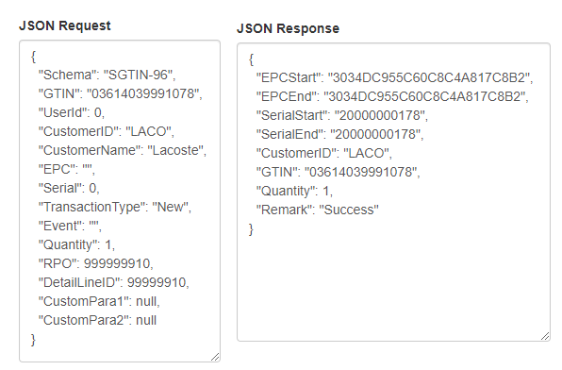

The affected tables are ‘tblEPCSerila’ and ‘tblEPCLog’

EPC Encoder/Decoder tool

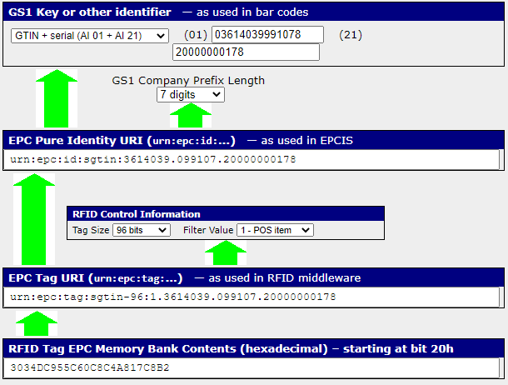

- Inditex

Serial number start: 1500000.
Serial number end: 4294967295

Json Request & Response

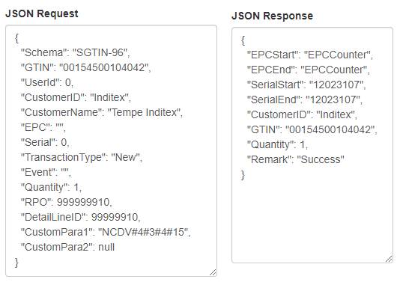

The affected tables are ‘tblEPCSerila’ , ‘tblEPCLog’ and ‘tblEPCCounter’

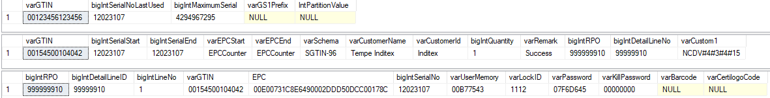

Please note that we are using GTIN "00123456123456" for serial number increment.

- State of Art

Serial number start: 100000000000.
Serial number end: 0

Json Request & Response

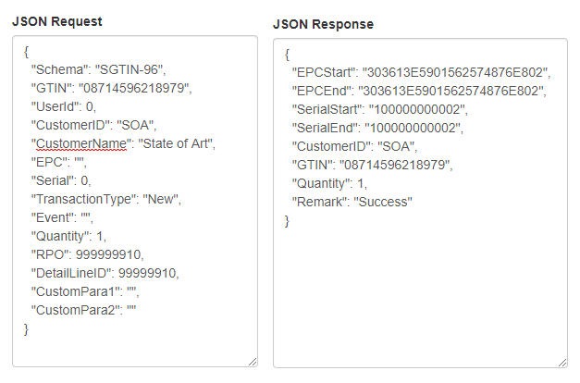

The affected tables are ‘tblEPCSerila’ and ‘tblEPCLog’

EPC Encoder/Decoder tool

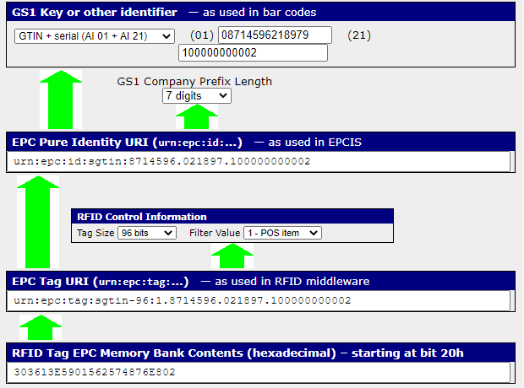

- Babyshop

We are adding prefix 4 in serial number (40000000000).

Json Request & Response
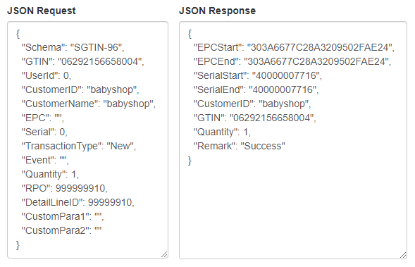

The affected tables are ‘tblEPCSerila’ and ‘tblEPCLog’

EPC Encoder/Decoder tool

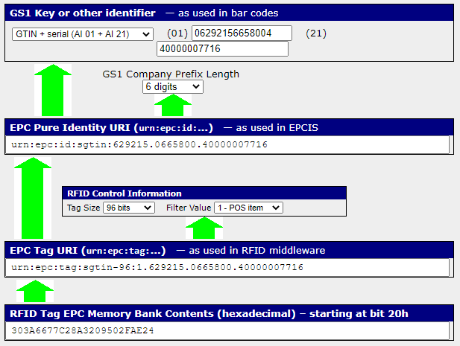

- C&A
Serial number start: 8589934592.
Serial number end: 12884901887

Json Request & Response
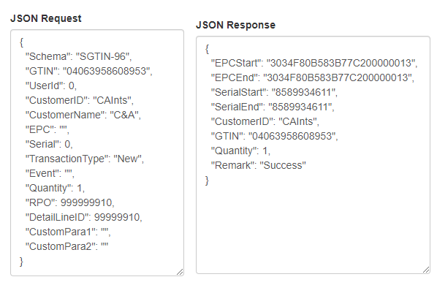

The affected tables are ‘tblEPCSerila’ and ‘tblEPCLog’

EPC Encoder/Decoder tool

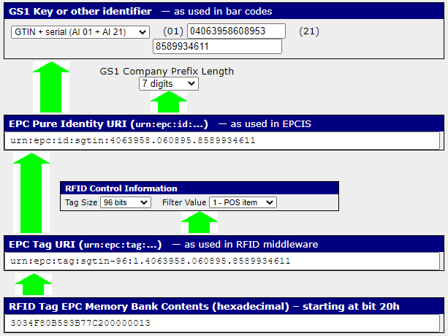

- Encuentro Moda

Serial number start: 0
Serial number end: 0

Json Request & Response
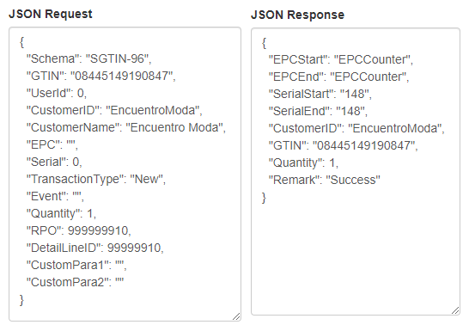

The affected tables are ‘tblEPCSerila’ , ‘tblEPCLog’ and ‘tblEPCCounter’

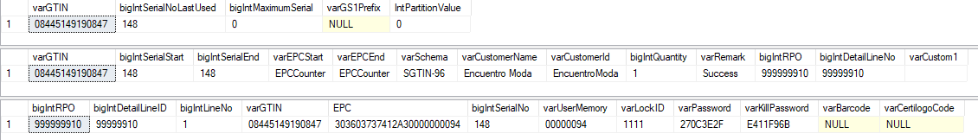

EPC Encoder/Decoder tool

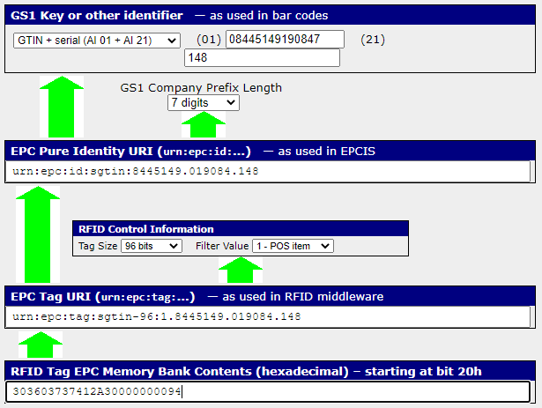

- Kennedy Space Center

Serial number start: 0
Serial number end: 0

Json Request & Response
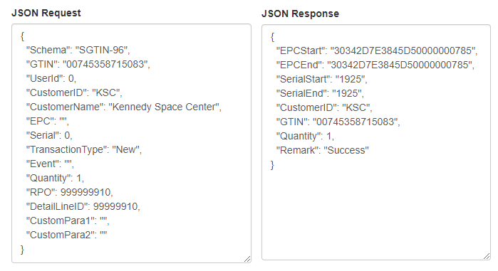

The affected tables are ‘tblEPCSerila’ and ‘tblEPCLog’

EPC Encoder/Decoder tool

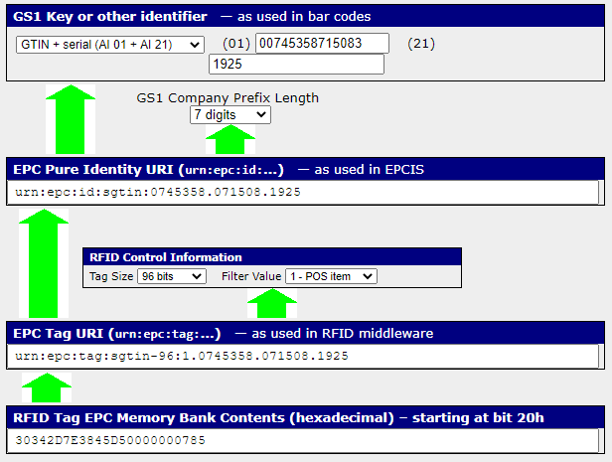

- Moose Knuckles

Serial number start: 1000000
Serial number end: 0

Json Request & Response
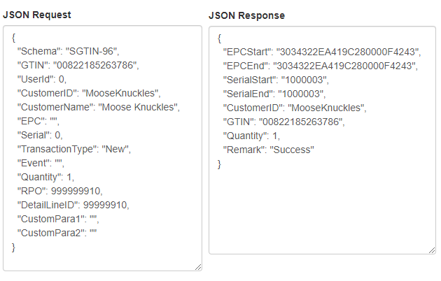

The affected tables are ‘tblEPCSerila’ and ‘tblEPCLog’

EPC Encoder/Decoder tool

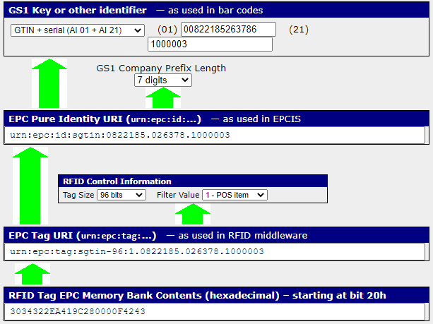

- Lindex

Serial number start: 0
Serial number end: 9999999

Please note that we are maintaining serial numbers.

Json Request & Response

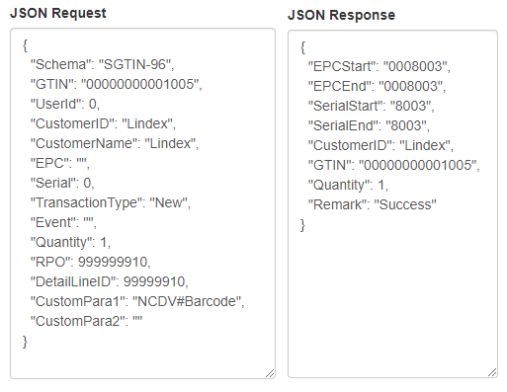

The affected tables are ‘tblEPCSerila’ and ‘tblEPCLog’

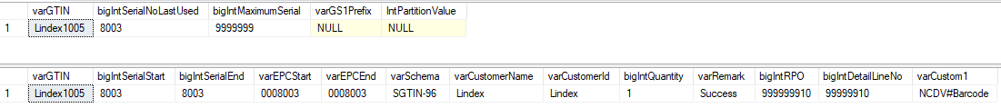

- Diesel

Serial number start: 0
Serial number end: 0

Json Request & Response
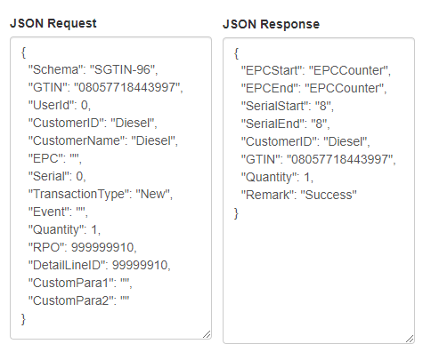

The affected tables are ‘tblEPCSerila’ , ‘tblEPCLog’ and ‘tblEPCCounter’

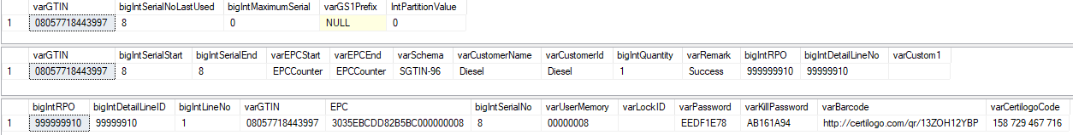

EPC Encoder/Decoder tool

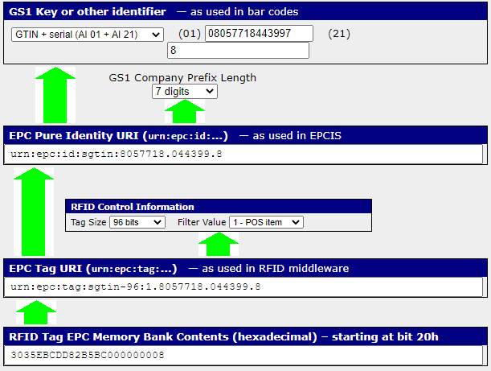

- MANGO

Serial number start: 17280532480
Serial number end: 17314086911

Json Request & Response
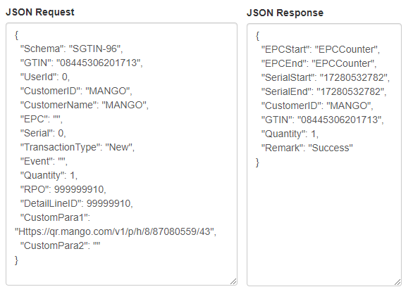

The affected tables are ‘tblEPCSerila’ , ‘tblEPCLog’,‘tblEPCCounter’ and ‘tblGS1CustomerDetail’

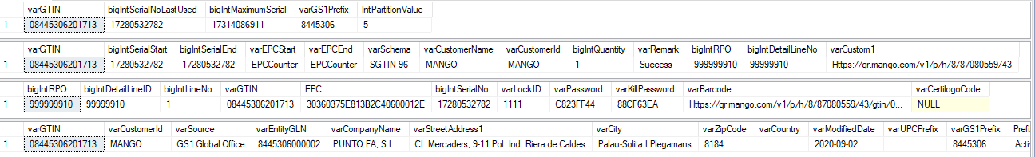

EPC Encoder/Decoder tool

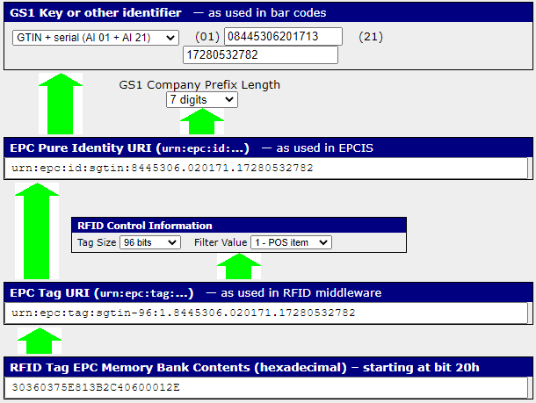
MANGO – Item Code: SSW

Serial number start: 51640270849
Serial number end: 51673825279

Json Request & Response
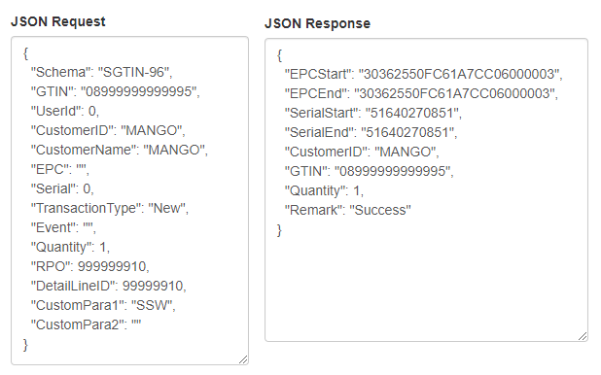

The affected tables are ‘tblEPCSerila’ , ‘tblEPCLog’ and ‘tblGS1CustomerDetail’

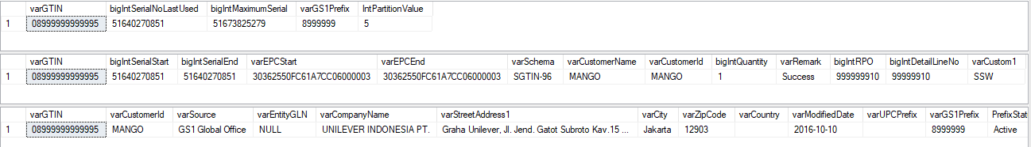

EPC Encoder/Decoder tool

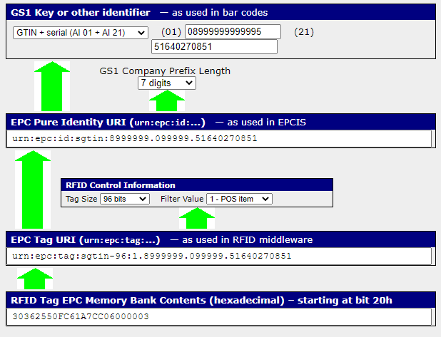

- BlueFields

Serial number start: 100000000000
Serial number end: 0

Json Request & Response
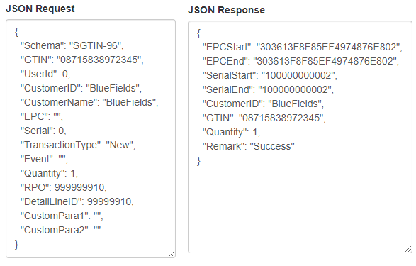

The affected tables are ‘tblEPCSerila’ and ‘tblEPCLog’

EPC Encoder/Decoder tool

